April 27 & 28, 2019  Join us for this exciting training. In this experiential 2-day program, you will learn about and practice Laughter Yoga, a full body wellness workout. You will also explore the physical, emotional, & psychological benefits that laughter yoga provides!  There are no Yoga poses and no comedy routines, a sense of humor is not required, nor does one need to be happy!  We don’t Laugh because we are happy, We are Happy because we laugh! We combine Laughter exercises with joyful play and fun movement. We add in eye contact in a group setting along with the deep breathing of Yoga (pranayama/yogic breathing). Finally, we learn guided meditation and relaxation, for an experience like no other. |  | Address  520 Prospect Avenue  West Orange, NJ 07052  contact us  Joan’s Laughter Yoga Training  | 201.240.5073 |  Joan.zarod@gmail.com  www.laughteryoganj.com  Be the Change you want to see in the world! |  | April 27 & 28, 2019  2 Day Laughter Yoga Leader training  REGISTER EARLY for only $299.  Full Registration is $325  Refresher rate of $100

Who should train?  - Teachers  - therapists  - activities directors (13 CE hours)  - yoga instructors  - HR directors  - nurses & Pysicians  - parents/grandparents  - anyone who wants to improve their wellbeing  - Anyone who experiences stress, anxiety or loneliness  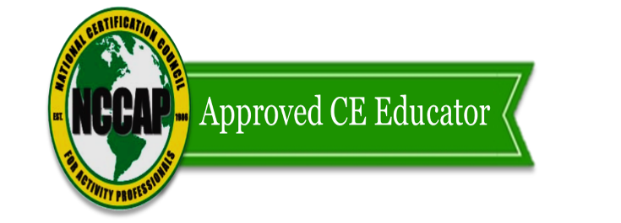  13 Conct Hours for Activities Professionals, certified by NCCAP |  | about the instructor  Joan Castellano is a Certified Laughter Yoga Teacher by Laughter Yoga International. Founded in 1995 by Dr. Madan Kataria.  She is CPR certified, insured and has a Master’s in Higher Education Administration from Teacher’s College, Columbia University. She facilitates laughter yoga at colleges, senior living, community centers, staff retreats, hospitals, private parties, anywhere there is a need for more laughter, connection and sharing of positive emotions.  Her life transformed after completing her 2-day Laughter Yoga Leader training in 2013. 2 months after her training she met and then married a wonderful man; at 49 years old! She lost 40 lbs. and maintains that loss. She connects easily with others and loves to share all that she has learned with like-minded individuals. Come see what all the fun is about! |  | Trust me: I’m a Laughter Professional  - Joan Castellano -

